|  |  |  |  |  |  |  |  |  |
| --- | --- | --- | --- | --- | --- | --- | --- | --- |
| Kode  KZS 559 | Brand | Material | Qty PO | Size | Harga | Aksesoris : | | |
| **KUZATURA NC**  **Warna : Coklat** | Spek :  Bahan = Full Suede  Tatak = Mangkok  Sol = Eva | 20 | 39 : 3  40 : 4  41 : 4  42 : 4  43 : 3  44 : 2 | Harga Deal :  Rp. 93.000 (Kotor) | Dus = 4.850  Tisu = 500  Striker = 150  Hangtag = 1.000  Yout New = 1100 | Total  Aksesories :  7.600 |

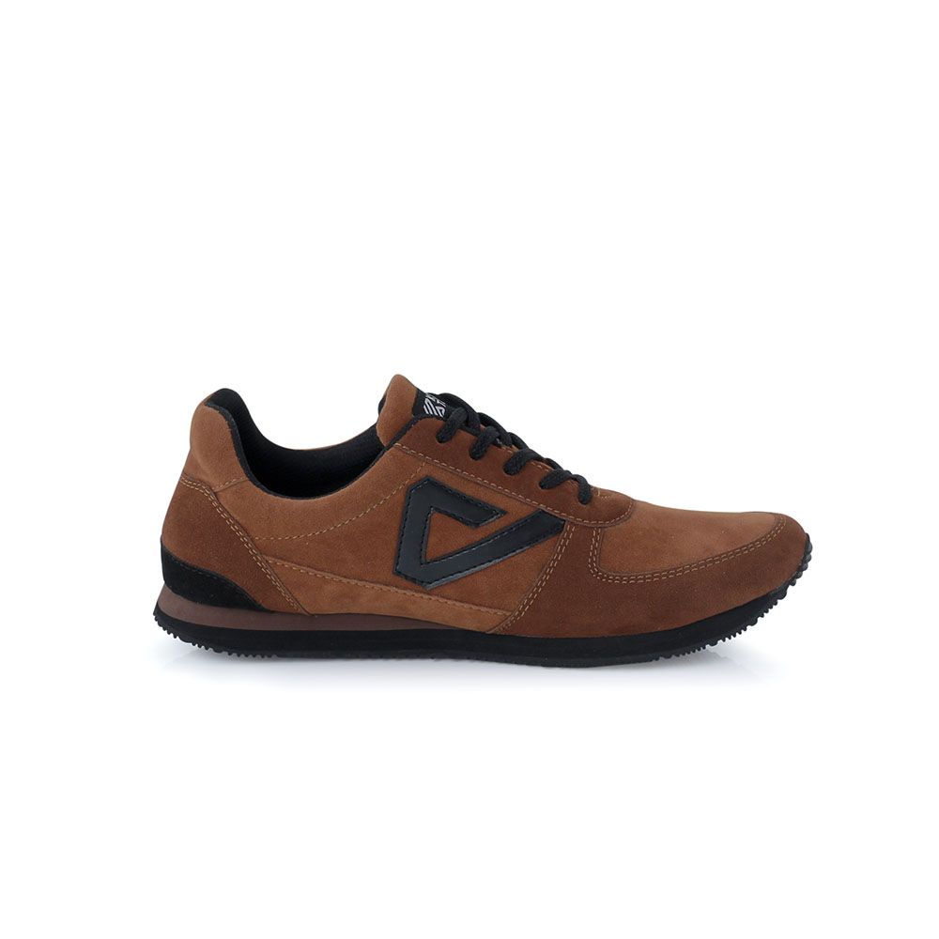

Woven

