|  |  |  |  |  |  |  |  |
| --- | --- | --- | --- | --- | --- | --- | --- |
| Kode  KZS  064 | Brand | Material | Qty PO | Size | Harga | Aksesoris | |
| Kuzatura | -Webing  -Kew-kew  -Kancing | 25 | All Size | Harga Deal  Rp.4.500 (Bersih) | Label 1 Sisi Kuzatura | Harga  Rp.250 |

Catatan:

Webbing

Kewkew sesuai sample

Label 1 sisi KUZATURA

Kancing   
Sesuai Sample

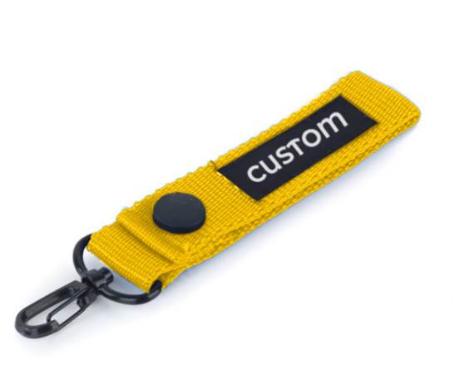

REFERENSI BRANDING DI BRAND LAIN

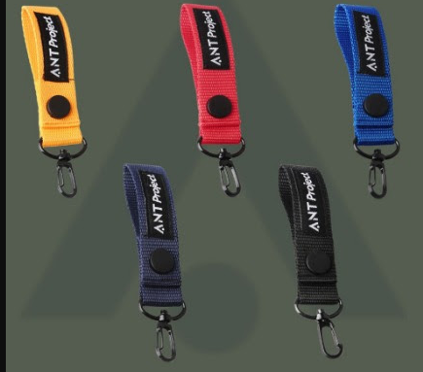

Form Nego   
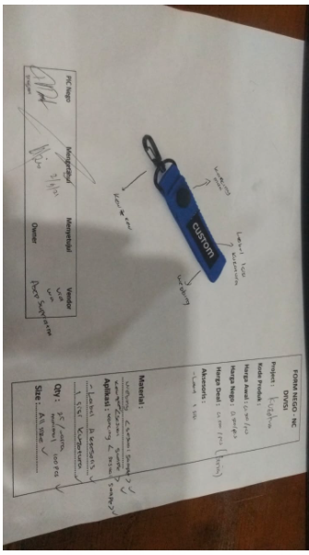

REFERENSI PENJUALAN DI ECOMMERCE

https://shopee.co.id/ANT-PROJECT-Keychain-Webing-Nylon-Premium-i.239741369.3947911272

z`

DLL