|  |  |  |  |  |  |  |  |
| --- | --- | --- | --- | --- | --- | --- | --- |
| Kode  LJB 054 | Brand | Material | Qty PO | Size | Harga | Aksesoris | |
| Blackkelly NC  Warna :  Tosca kom Kuning dan Coklat | Bahan : D 300 | 40 | AllSize  Uk: 51X33X20 | Harga Deal  Rp. 80,950 (kotor) | Hangtag : 600  Slip Kain : 250  Label ID BCL : 250  Plastik XL : 1.600 | Total Harga :  Rp. 2,700 |

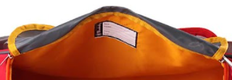Catatan:

Tali Warna Abu

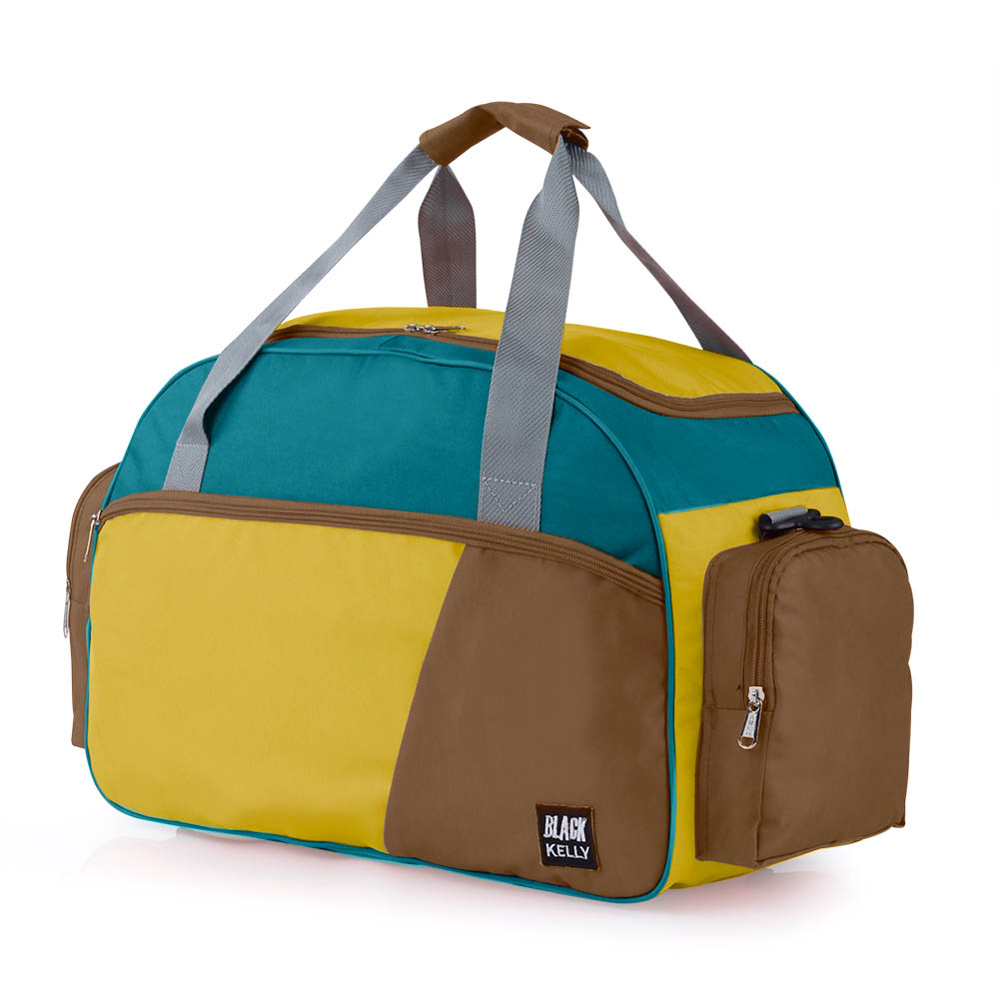

Warna Tosca

ID Card Dibagian dalam Tas

Warna Kuning

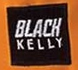

Warna Coklat

Logo Blackkelly dibordel

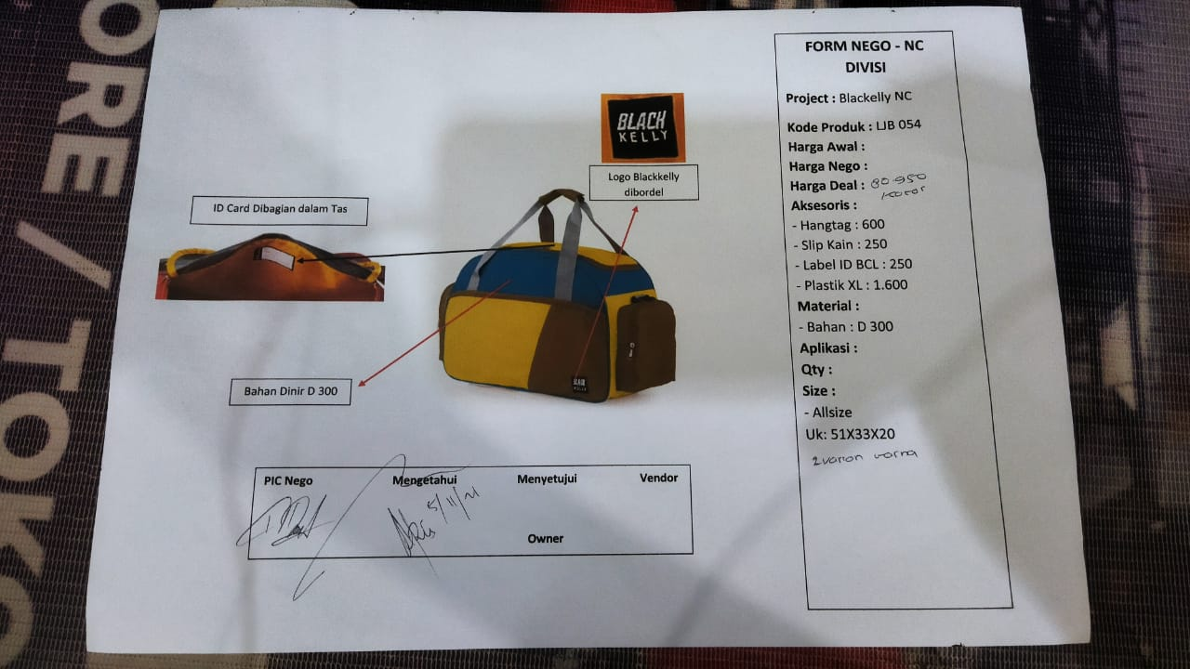REFERENSI BRANDING DI BRAND LAIN

REFERENSI PENJUALAN DI ECOMMERCE

DLL