|  |  |  |  |  |  |  |  |
| --- | --- | --- | --- | --- | --- | --- | --- |
| Kode  TL 713 OTVN | Brand | Material | Qty PO | Size | Harga | Aksesoris | |
| D:\Rafly\PO\NEGO\TL 713.jpgOutvin | Bahan : Cordura  Warna : Maroon kom Hitam | 25 | All Size | Harga Deal  Rp. 19,000(Bersih) | Woven OTVN Hitam | 750  Total : Rp. 750 |

Catatan:

Bahan Cordura Marun

Bahan Cordura Marun



Woven Outvin Hitam dijahit Zigzag

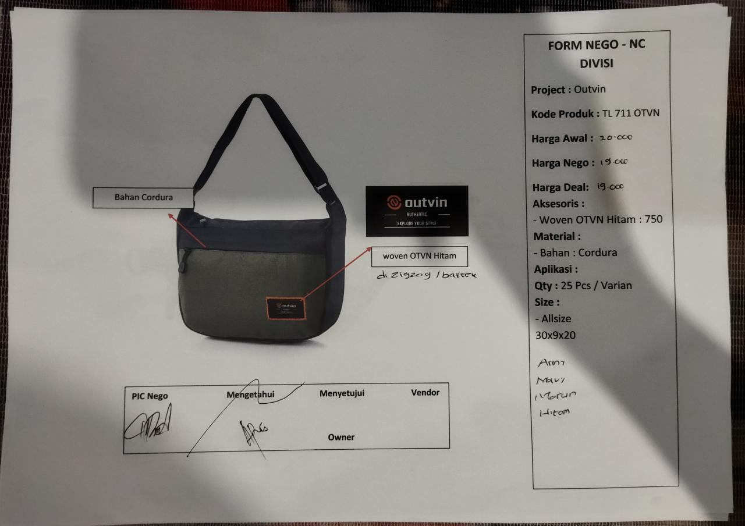REFERENSI BRANDING DI BRAND LAIN

REFERENSI PENJUALAN DI ECOMMERCE

DLL

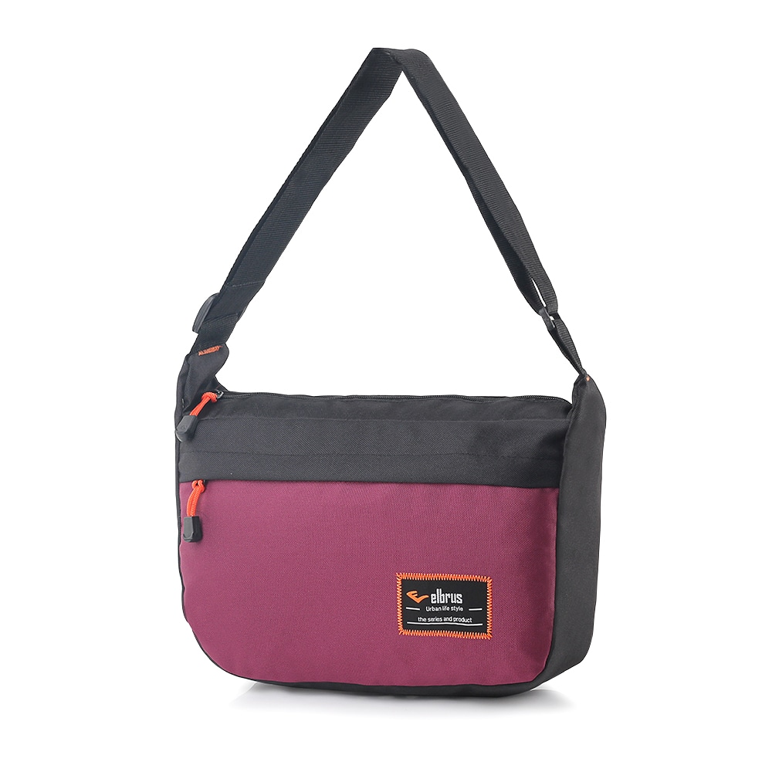**TL 713**