No | Jenis Aksesoris | Gambar | Fungsi | Harga produksi 2018 | Harga Produksi Sekarang | Selisih | Harga Supplier 2018 | Harga Supplier Sekarang | Keterangan
1 | Dus Dompet Pria | 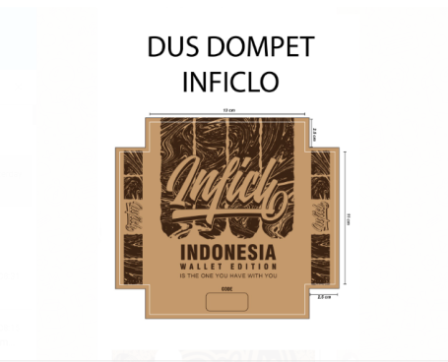 | - Dompet Pria | 1.550 | 1.500/pcs (min. Order 3.000 pcs)  1.550/pcs (min. Order 1.000 pcs) | Naik 50  Sama | 1.600 | 1.650 | Buffer 100
2 | Dus Fashion Inficlo besar | 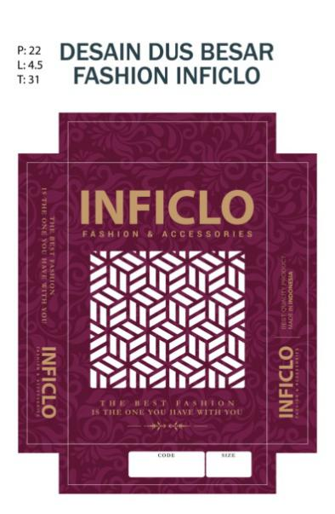 | - Gamis | 3.000 | 2.950/pcs (min. Order 3000 pcs)  3.000/pcs (min. Order 2.500 pcs) | Turun 50  Sama | 3.000 | 3.100 | Buffer 100
3 | Dus Fashion Inficlo Kecil | 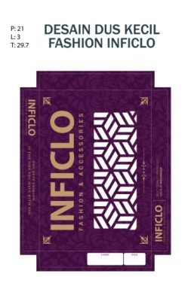 | - Gamis | 2.800 | 2.775/pcs (min. Order 3.000 pcs)  3000/pcs (min. Order 2.500 pcs) | Turun 25  Sama | 3.000 | 3.000 | Buffer 225
4 | HANGTAG | 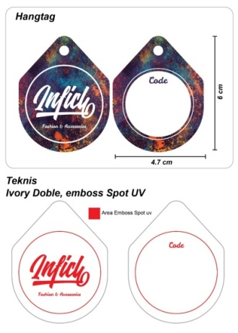 | - Fashion Pakaian | 450 | Embos500/pcs (12.000 order di awalaja)  Biasa425/pcs (12.000 order di awalaja)  Repeat bisa 6.000 | Naik 50  Turun 25 | 500 | 600 | Buffer 100
5 | SLIP KARET | 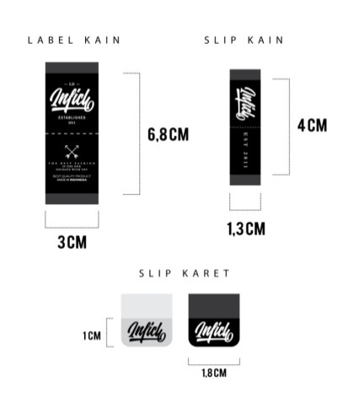 | - Tas | 200 | 200/pcs (Min Order. 2.000 pcs) | Sama | 300 | 300 | Buffer 100 | Hanya yang warnaputihbeningsaja
6 | LABEL KAIN LACOSTE | 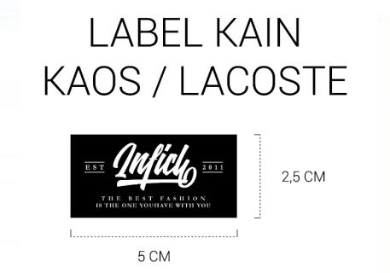 | - Lacoste  - Kaos  - kemeja |  | 2.750/lusin, Satuan229, Miniam 6000 Lusin  229/pcs |  | baru | 300 | Buffer 71
7 | LABEL KAIN SAKU | 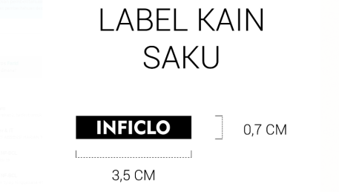 | - Lacoste  - Kaos  kemeja |  | 1500/lusin, Satuan125, Minimal 6000  125/pcs |  | baru | 200 | Buffer 75
8 | SLIP KAIN | 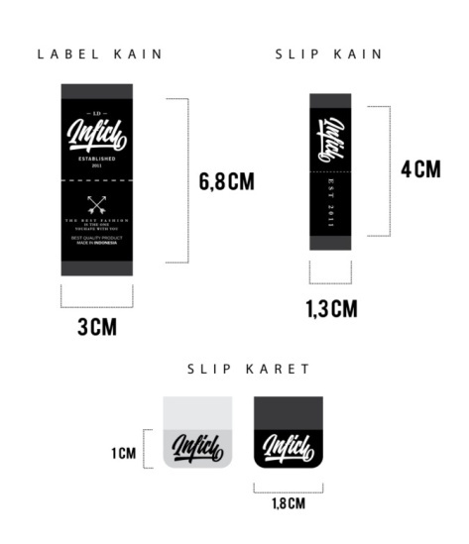 | - Pakaian  - Tas | 117 | 133 / pcs (Min Order 6.000 pcs) | Naik 16 | 200 | 200 | Buffer 67
9 | LABEL KAIN | 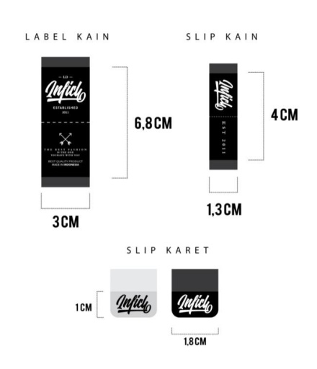 | - PakaianPundak | 264 | 279/pcs (Min Order 6.000 pcs) | Naik 15 | 300 | 350 | Buffer 121
10 | LAKEN S | 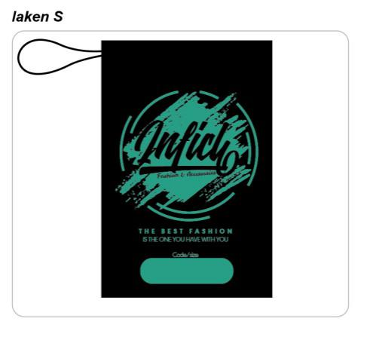 | - DompetCowok | 1.750 | 1.850 | Naik 100 | 1.750 | 2.000 | Buffer 150
11 | LAKEN M | 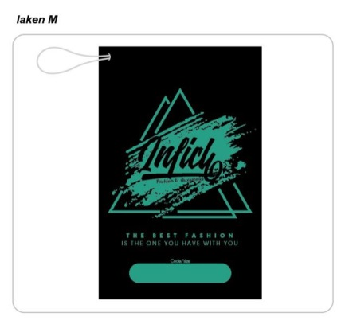 | - Dompet Model PanjangCe/Co | 2.350 | 2.450 | Naik 100 | 2.350 | 2.500 | Buffer 150
12 | LAKEN L | 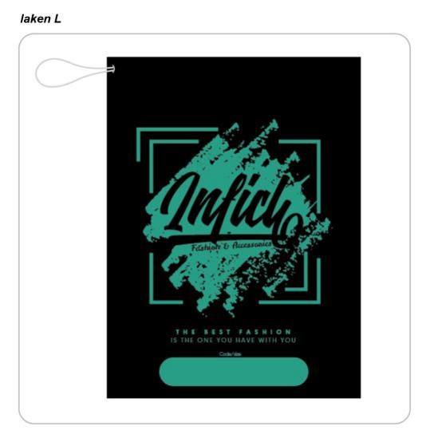 | -TasPria/Wanitaukuran Normal | 2.850 | 3.000 | Naik 150 | 2.850 | 3.000 | -
13 | LAKEN XL |  | - TasPria/BackpagBesar  - JaketMotor | 3.450 | 3.600 | Naik 150 | 3.450 | 3.600 | -
14 | LABEL KULIT WOVEN TAS 1 | 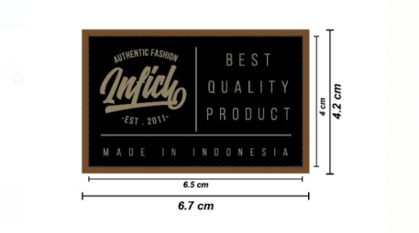 | - TasBackpag/Samping Co | Belum pernah sebelumnya | WOVEN 3.700 / Lusin (500 Dz)… 308,3  Kulit = 500/PCS (Min Order. 6.000)  808,3 |  |  | 950 | Buffer 141,7
15 | LABEL KULIT WOVEN TAS 2 | 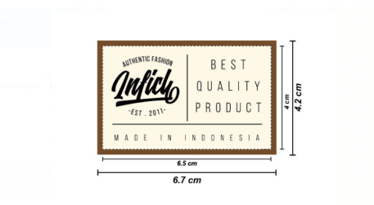 | - TasBackpag/Samping Co | Belum pernah sebelumnya | WOVEN 3.700 / Lusin (500 Dz)… 308,3  Kulit = 500/PCS (Min Order. 6.000)  808,3 |  |  | 950 | Buffer 141,7
16 | PLASTIK CETIK | 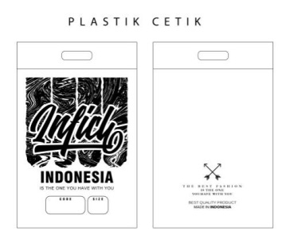 | - Fashion | 631 | Plastik = 1.075.000  (2000 PCS)537/PCS  Sablon 175/PCS  *537 + 175 = 712 / pcs | Naik 81 | 650 | 800 | Buffer 88 | -
17 | LABEL ID | 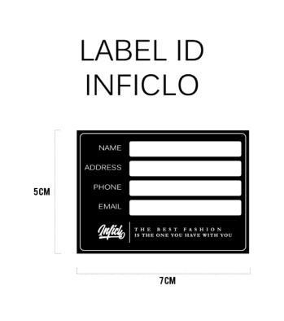 | DalamTas | 175 | 142/pcs (Min. 6000 pcs) | Turun 33 | 250 | 250 | Buffer 108 | -

AKSESORIS LAMA
16 | LOGAM COR NIKEL | 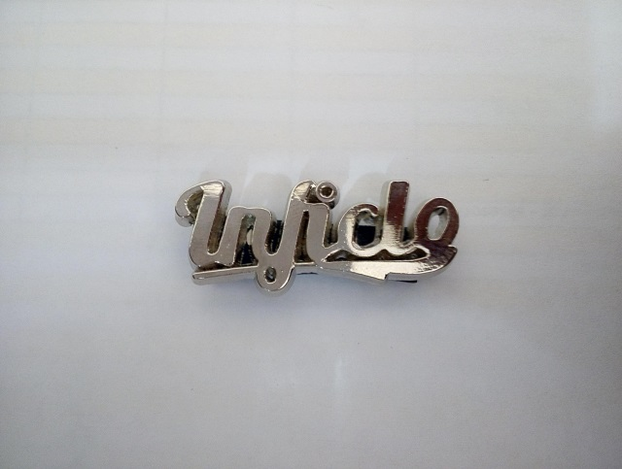 | Tas wanita  Dompet wanita  Tas samping pria  Dompet pria | 530 | 650 |  | 550 | 650 | Buffer 100

17 | LOGAM COR BAKAR | 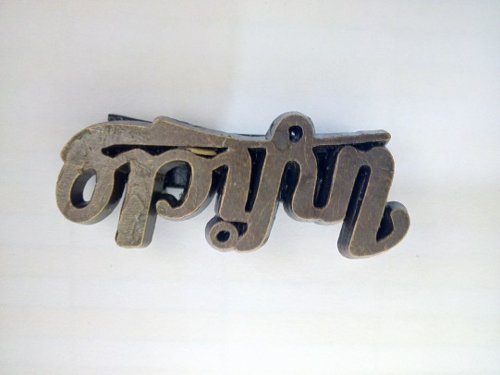 | Tas wanita  Dompet wanita  Tas samping pria  Dompet pria | 680 | 800 |  | 700 | 800 | Buffer 100

18 | LOGAM COR EMAS | 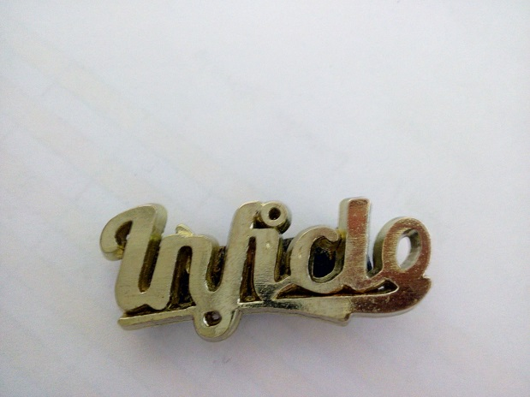 | Tas wanita  Dompet wanita  Tas samping pria  Dompet pria | 930 | 1.000 |  | 950 | 1.100 | Buffer 170
19 | KULIT LUBANG 2 PUTIH | 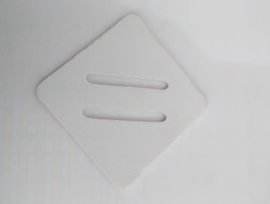 | Tas pria | 700 | 800 |  | 700 | 800 | Buffer 100
20 | KULIT LUBANG 2 COKLAT | 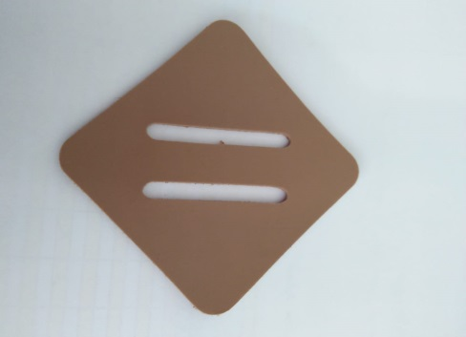 | Tas Pria | 700 | 800 |  | 700 | 800 | Buffer 100
21 | KULIT LUBANG 2  F | 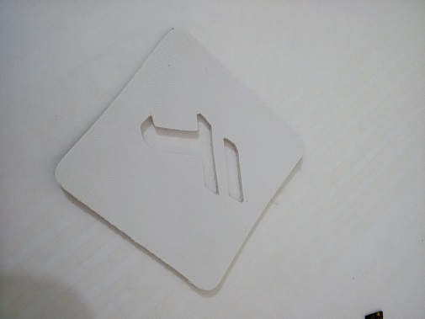 | Tas Pria | 700 | 800 |  | 700 | 800 | Buffer 100
22 | KULIT TAS 2 | 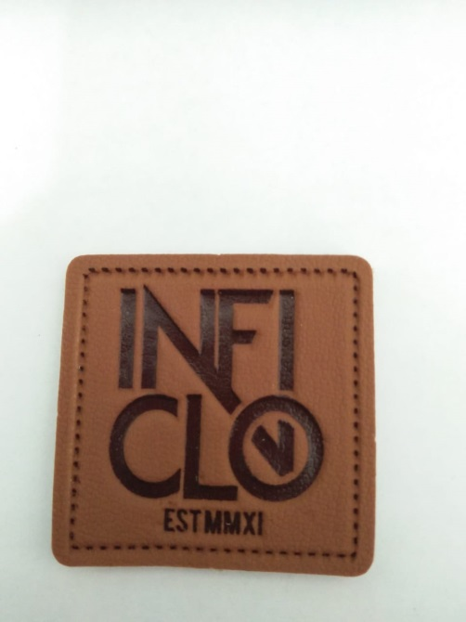 | Tas Pria | 600 | 700 |  | 600 | 700 | Buffer 100
23 | KAIN TAS PUTIH | 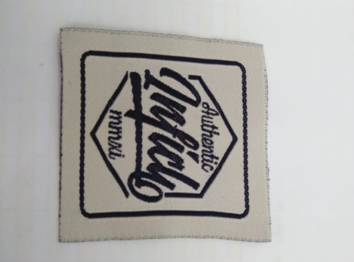 | Tas Pria | 667 | 800 |  | 667 | 800 | Buffer 123
24 | KAIN TAS HITAM | 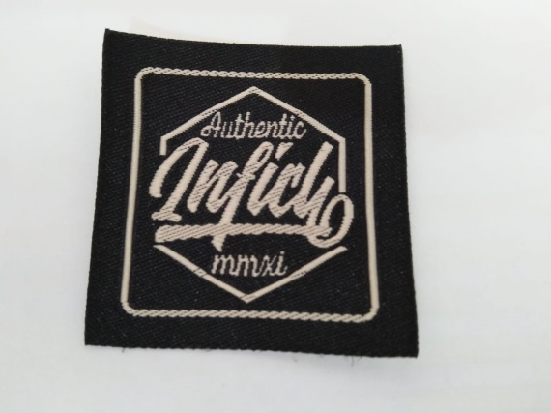 | Tas Pria | 667 | 800 |  | 667 | 800 | Buffer 123
25 | KULIT KETUPAT INFICLO | 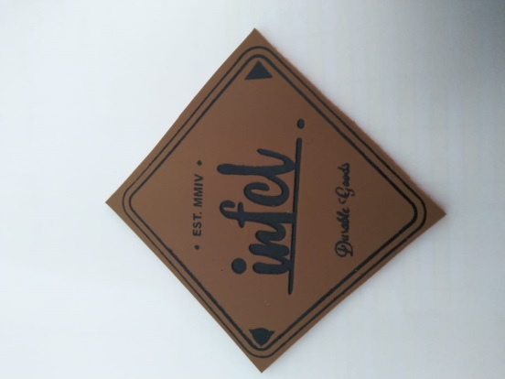 | Tas Pria | 1.000 | 1.000 |  | 1.000 | 1.000 | Sama

26 | LABEL KULIT JEANS CO | 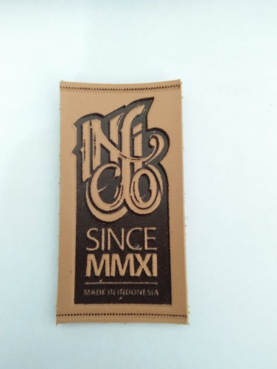 | Clana Pria | 650 | 750 |  | 650 | 750 | Buffer 100

27 | KULIT TAS 1 | 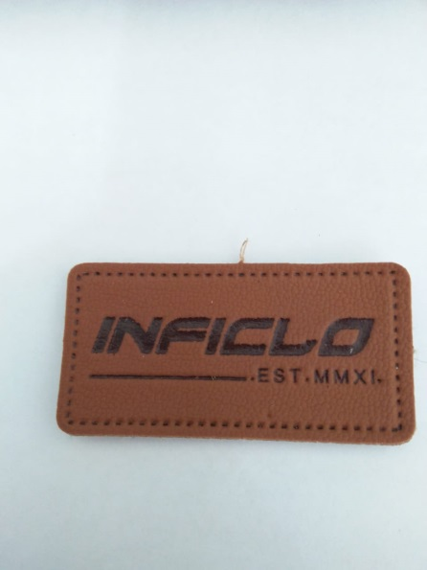 | Tas Pria | 600 | 700 |  | 600 | 700 | Buffer 100
28 | LABEL KULIT JEANS CE | 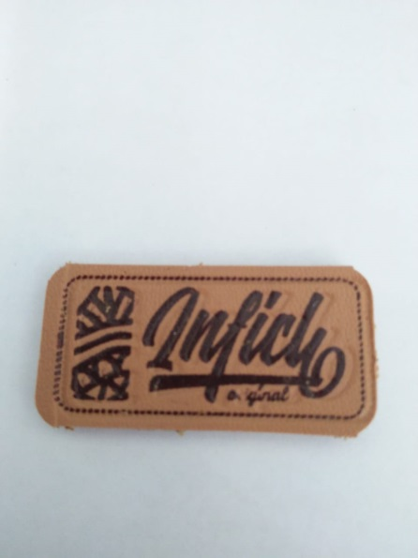 | Dompet Pria  Clana Wanita | 550 | 650 |  | 550 | 650 | Buffer 100
29 | PLASTIK CETIK KECIL |  | Jilbab |  | 500 |  |  | 600 | Buffer 100
30 | LOGAM KALENG |  | Dompet wanita  Tas wanita | 700 | 1.000 | 300 | 1.000 | 1.000

